1 |  | Flashing green: the initial self-check was successful and the alarm is now ready to connect the sensor  Continuous green: connection of the sensor successful and monitoring function is working
2 |  | Flashing yellow battery: battery is being charged – alarm system cannot be started until charging is complete
3 |  | Flashing yellow warning:  -the sensor has come in contact with moisture (saturated)  -the sensor has come lose, is not connected, or is broken  -the fiber optic cable is not connected correctly  Turn alarm unit off and fix the cause of the warning.  If any other technical issue occurs, switch to another Redsense alarm unit and contact Redsense Medical for additional support.
4 |  | Flashing yellow warning + battery with intermittent tone: the alarm unit is no longer receiving power from the AC adapter – monitoring can no longer be performed correctly – turn alarm unit off and fix the cause for the power failure.
5 |  | Flashing red with continuous alarm: blood has been detected either due to venous needle dislodgement or leakage has occurred – first, deal with the leak, then turn the alarm off
6 |  | Solid all lights: initial self-check of the alarm unit, press start button again and should go to 1, flashing green.  Flashing all lights with intermittent tone: internal error has been detected – contact Redsense Medical for additional support
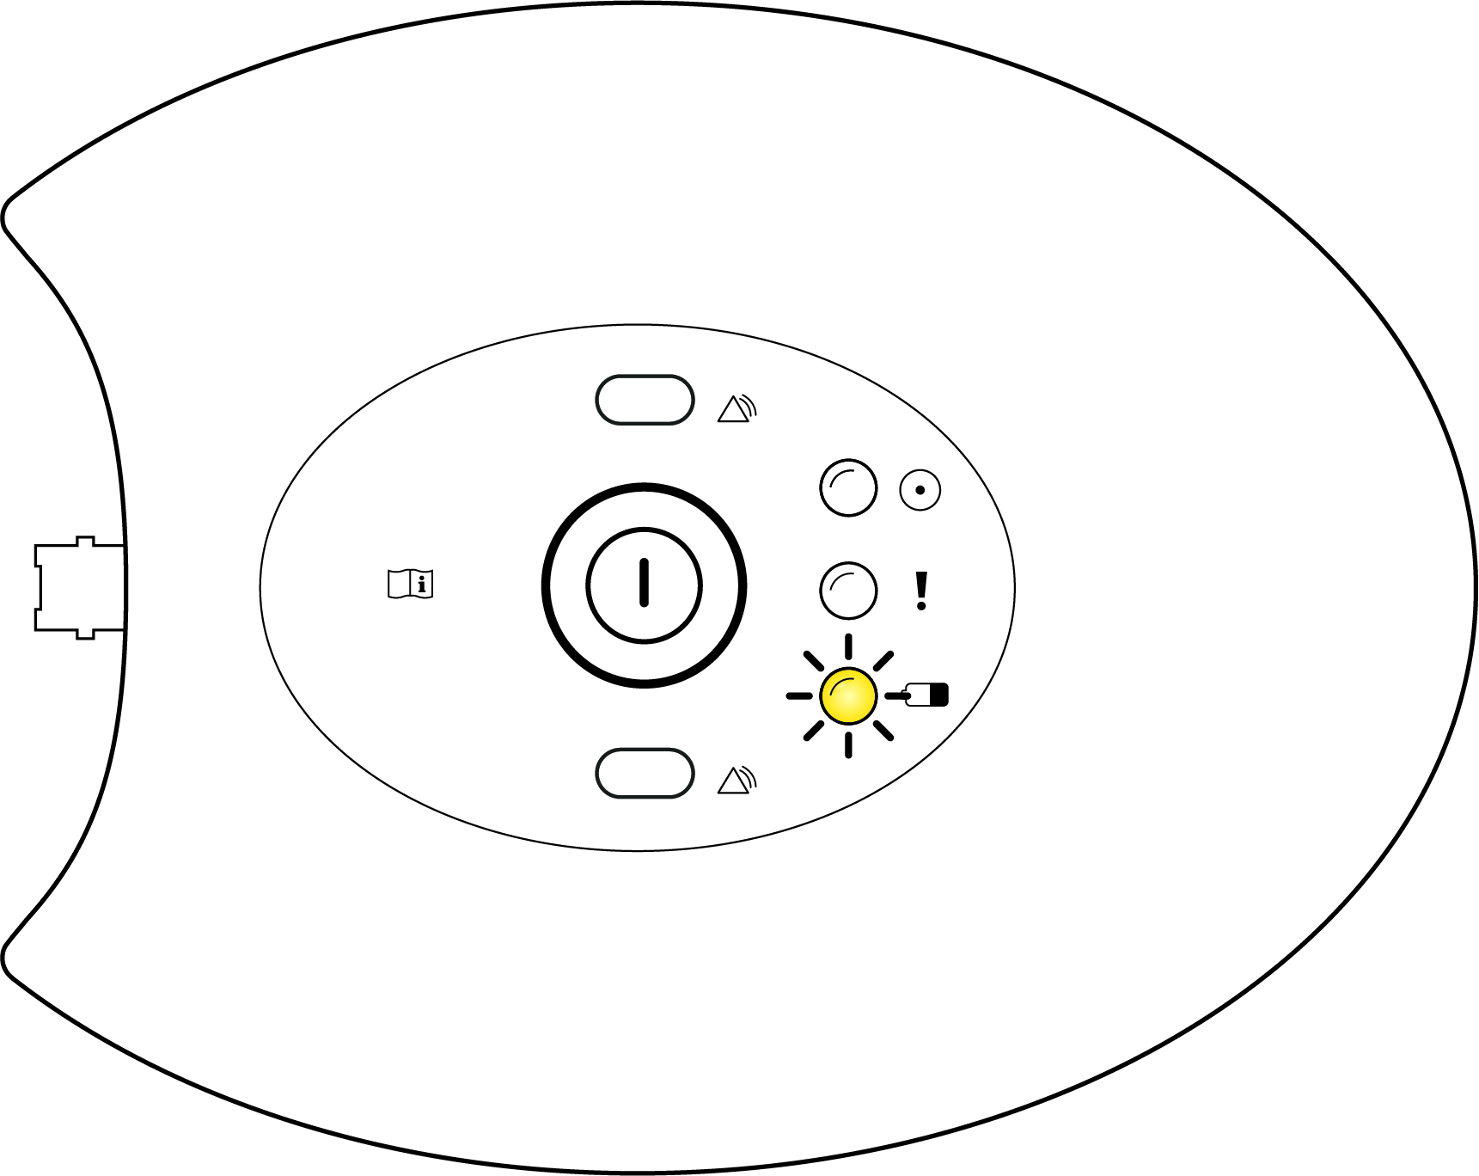
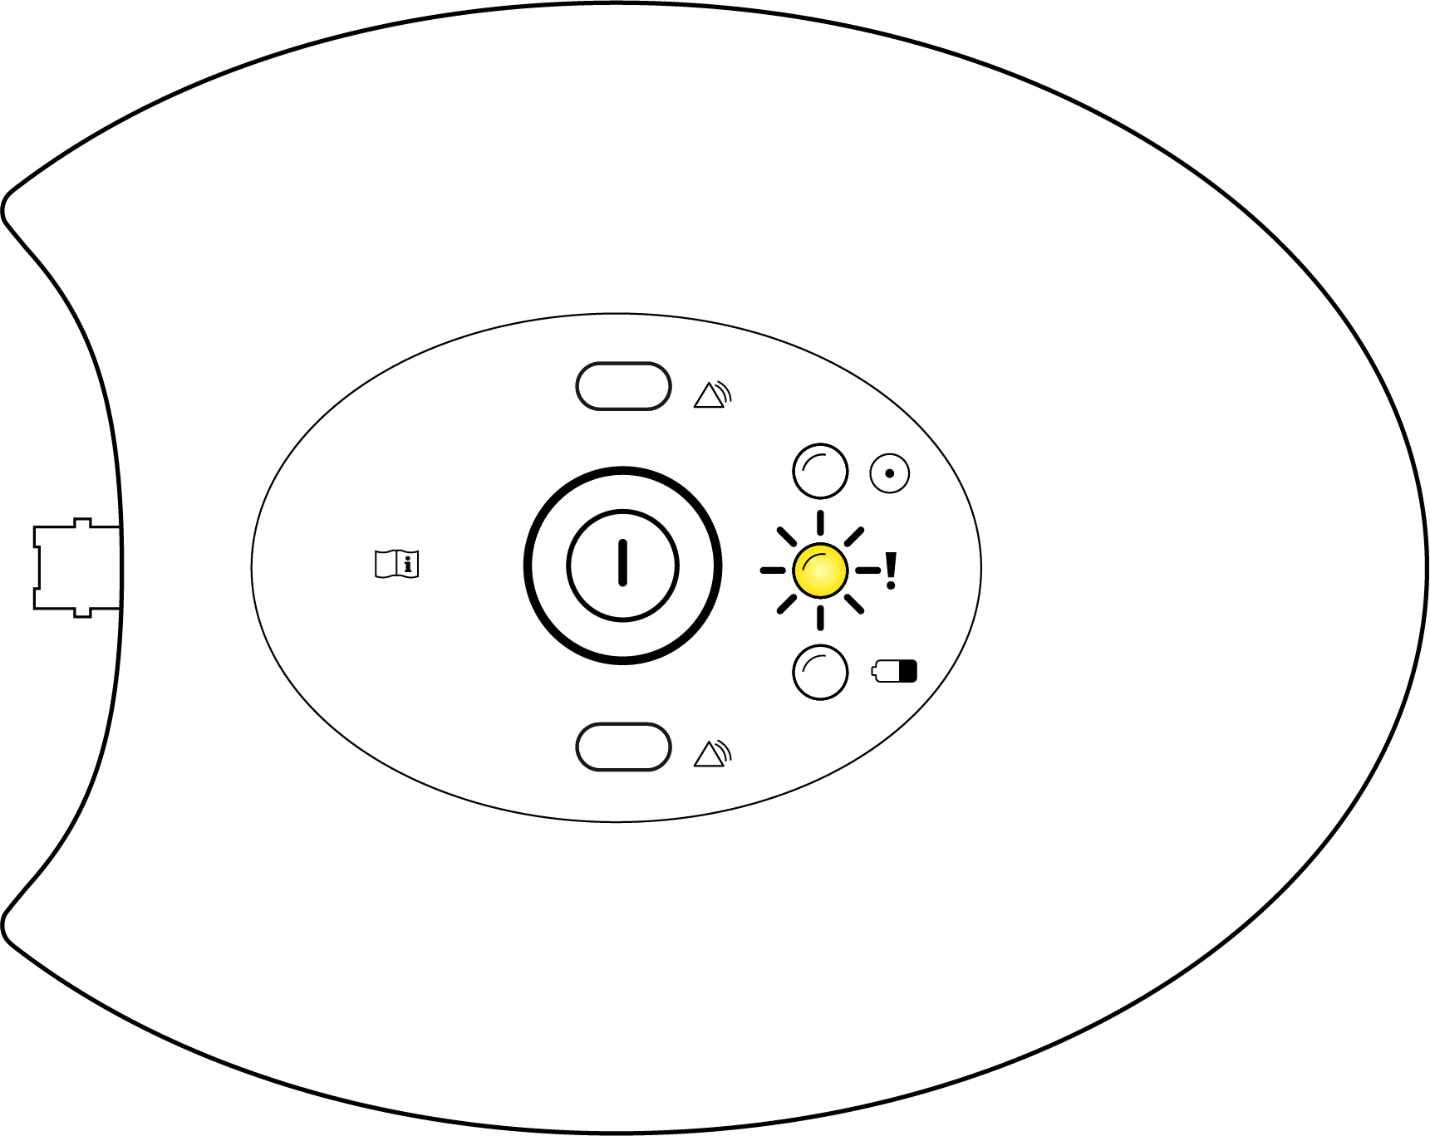
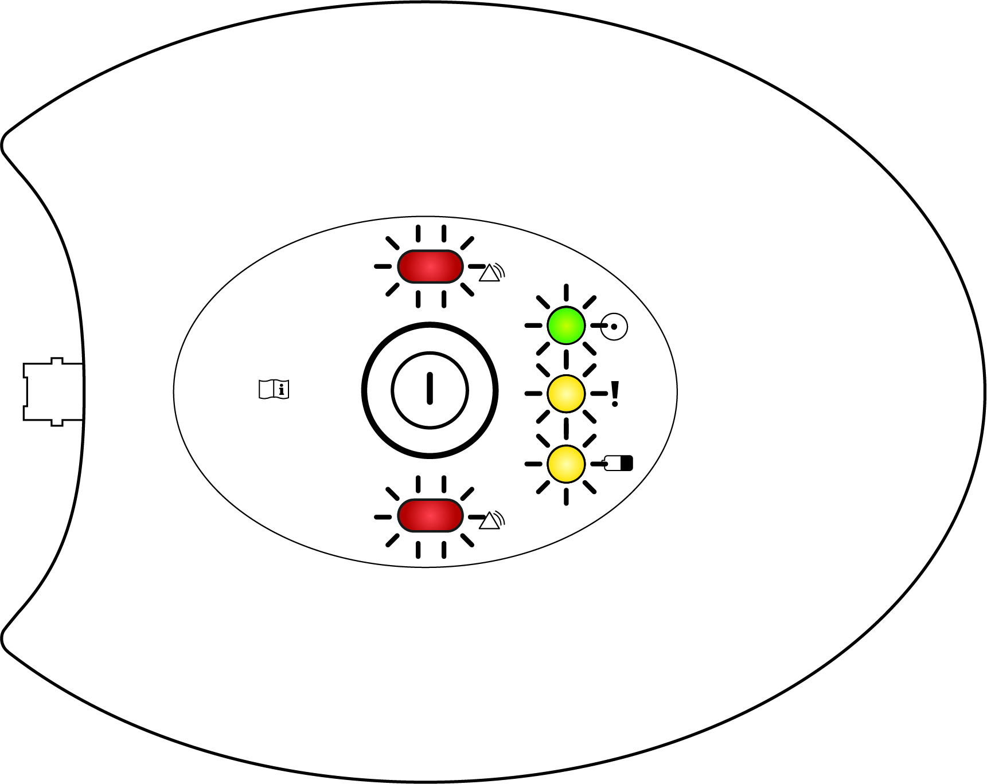
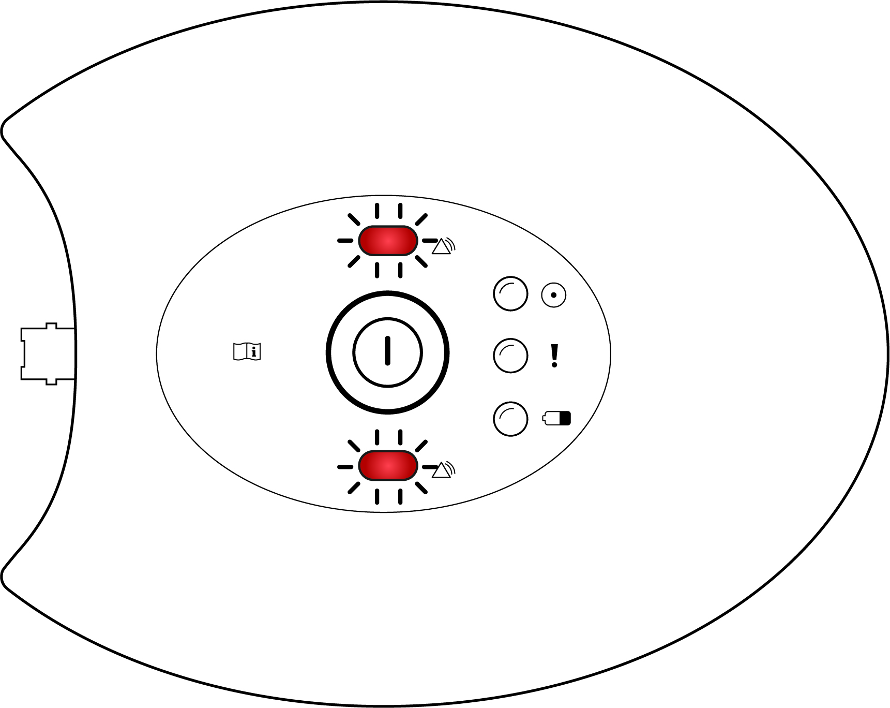
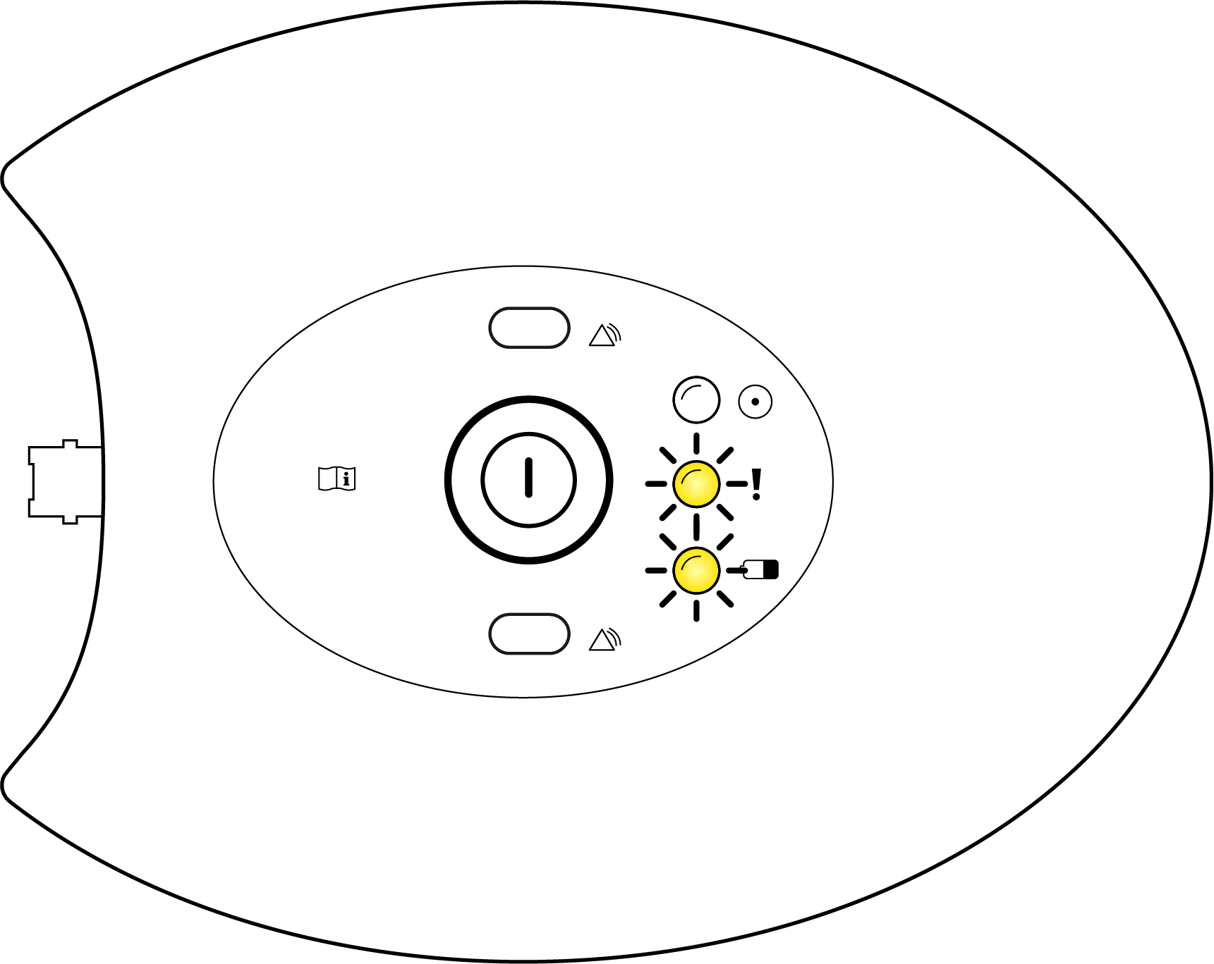
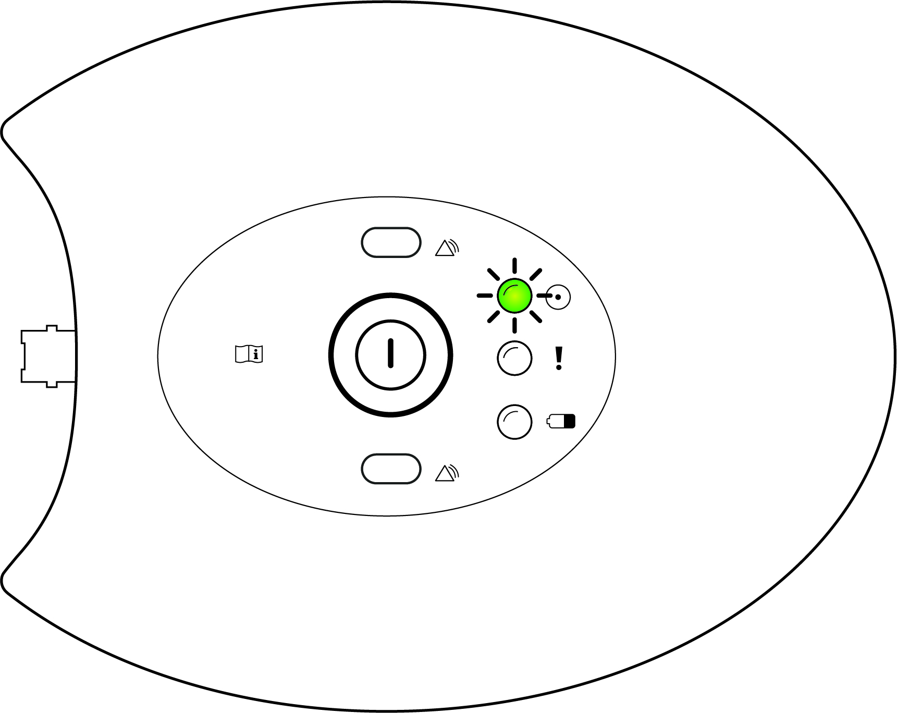
RM-1-RM240

Possible Alarms and Warnings

